Manheim Denver Training Notes
July 25th, 2014

SESSION PURPOSE
To go from good to great- greatness starts with the individual…. great teams made up of great individuals. Move from 45th to 15th overall.

SESSION OBJECTIVES
- Improve Team Communication
- Identify our “Great”
- Learn new leadership tools & perspectives
- Apply learning to current situation & commit to at least 1 action item
- Establish accountability

PARTICIPANT OBJECTIVES
- Tasks- explain them- ask if you are unclear
- Tasks- how are you held accountable/consequences (none = low on priority list)
- More transparency - what and why we’re doing it
- Cross training because we have less people
- Knowledge of other department objectives
- Customer Service- our products are always last minute so the quality is there so we’re rushing; plan ahead.
- Teamwork & Smaller meetings- accomplish more & to develop a plan (i.e. Monday meeting - have the right people in the meetings we are having - what’s running in the lanes. idea- release those who don’t need to know)
- Understanding areas of the OPR
- Managers cross training with other departments

ROADMAP (Agenda for the day)
- Icebreaker
- Intro
- Set the foundation
- DiSC Communication Model
- New Leadership Perspective
- Review & Close

TEAM NORMS
- e manners
- Timeliness
- Headlines- jokes- avoiding reality
- Honest Feedback- avoid zingers
- Address the problem not the person
- Feed the good wolf

AHA FROM EARLY MORNING SESSION:
- The team is not 1 team? We need to become 1 if we are to succeed
- Resolve execution issues
- New way to work for better teamwork
- Explain/Explore tribes
- New peoples’ perspectives is much different
- Focus more on other’s needs
- Be more open minded; learn more about each area
- Communication-not everyone thinks the same/outside the box
- Get on Board- Become a better team together
- Embrace all ideas; celebrate failure
- I didn’t realize how different our thoughts were

AHAs FROM LATE MORNING SESSION
- Positive reinforcement
- Positive feedback
- Reward positives
- Be accountable to each other
- Who R the right people?
- People need positive feedback in order to do a better job
- Structure who comes to meetings
- Break down the barriers
- Team norms address the problem and not the person
- Captive environment
- Know what drives your team as individuals
- Focus
- New way to work for better teamwork
- Focus more on others’ needs

IDEAS FOR JEFF
- Accountability
- Priorities: Building w/o direction= No one is on the same page about what we are trying to accomplish
- Tracking: We don’t monitor what we’ve done.
- Different Perceptions

DiSC MODEL OF COMMUNICATION
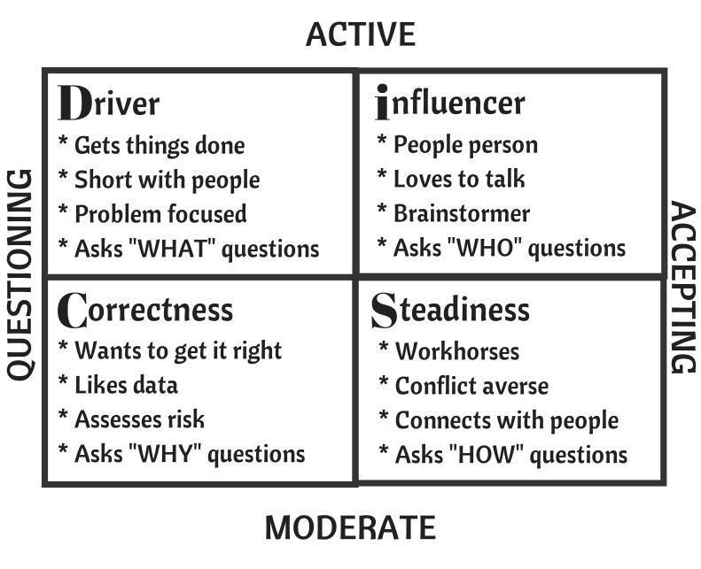

LEADERSHIP PERSPECTIVES
1. Pot Roast (“Why is it that way?”)
2. Bright sunshine vs. Dirty Window
3. Bricklayers vs. Cathedral Builders

IDEAL FUTURE (BRIGHT SUNSHINE)--What do we WANT it to look like?

1. Operation Efficiency
-tell the WHY -people buy-in
-lead by example -deadlines, accountability, prioritize
-presentation -empowerment
-a defined plan with clear objectives
-follow up -be a leader
-7Ps (proper planning prevents piss poor performance)
-correct staffing/are the right people in the right roles
-gut check -overcome your own fear

2. The Ideal Team Player
-open to change -loyal
-identify talent for the right positions
-be able to shift responsibilities to the “hot spot”
-accountable -wants to be here
-adaptability -mutually respectful
-positive -ownership
-vocal -motivated
-ambitious -free thinker
-limits -helpful

3. Our Dream Culture
-reward -respect
-enjoy -fun
-see the drea -happy customers
-$$$ -teamwork
-happy employees -no stirring the pot
-opportunity for growth -consequences for behavior for ALL
-4 day work week -agreement
-equality -quantity
-mutual respect

REAL PRESENT (DIRTY WINDOW)
1. Ideal Team Player (issues that prevent us from having this NOW)
-motivation -buy in
-want to -not empowered
-too many people without positive attitude
-shortage of manpower -lack of training
-newer staff doesn’t get the same opportunities as the veterans
-friend game -no team work
-always done that way -zero employee engagement
-lack of communication -don’t want to let go of favoritism

ACTIONS:
(1) held to same standards regardless of position (HR/MGT)
(2) everyone will be given the same opportunity for advancement of
change (HR/MGT)
(3) true confidentiality within management/HR (MGT/HR)
(4) give employees respect by spending time with employees (MGT)
(5) 10 at 10 (MGT)
(6) take ownership of their actions (EMPLOYEES)
(7) new rewards/ employee recognition (MGT)
(8) understanding your team/ where they fall on the DiSC model (MGT)
(9) knowing the why’s - the effects on other departments (both managers
& employees)
(10) clear understanding of what you can/can’t do
*** Are the right people in the right jobs? Are people at the right
meetings? (MGT/HR/SR LEADERS)

2. Operation Efficiency (issues that prevent us from having this NOW)
-knowing the goal -get over it -personnel
-no follow up -numbers aren’t true
-people being lazy -distrust -favoritism
-accept it- the new way -not enough time
-AS400 system boundaries -blame game -accountability
-won’t admit the problems -HR support
-plans are not clear and precise -no money -corporate support
-clear picture -too many upgrades
-easy way out -knowledge
-lack of knowledge -lack of support -communication -lack of effective communication -focus on too many things
-pick out top 5 problems -realize industry has changed

ACTIONS:
(1) spend the time to explain the vision of Manheim and how it affects the
industry changes
(2) twice a day, have 1 on 1 conversations with employees -curtail these
conversations to individuals by DiSC
(3) empowered employees with a sense of value & worth will make their
environment a dream culture

3. Our Dream Culture (issues that prevent us from having this NOW)
-trust -making time to do it
-envision winning -poor facility
-different rules -moving targets
-disrespect -support
-longevity -lack of funds
-employees do not buy-in -don’t want to adapt to change
-not empowered -defensiveness
-poor software -priorities are different

ACTIONS:
(1) KNOWLEDGE- inform folks of accounts and their needs, use the tools
available, describe importance
(2) SUPPORT- empower people better sales setup, movement tools in van
(3) COMMUNICATION- consistent/ informed leader
(4) PERSONNEL- roles & responsibilities; 10 mins of followup / pin point,
ask opinions

KEYS TO CHANGING CULTURE
1. Information
2. Motivation
3. Inspiration
4. Transformation

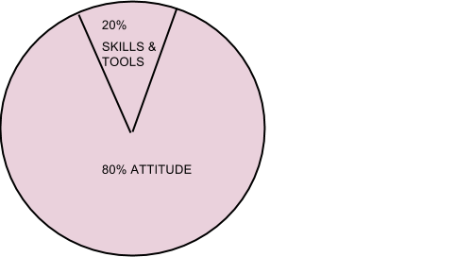

AHAs AFTERNOON SESSION 4:30
-really enjoyed DiSC
-OPR inform--half full/half empty--direction
-the pot roast--why is it that way?
-feeling more like we are on the same path
-who are the right people? --one Manheim Denver team
-reward positives--captive environment
-see the big picture
-smile
-one shared goal--focus
-everyone has same motivation-- just different ways to get there

ACTIONS
What | Who | When
Cross training conversation ref. employees | Lead = Mark  Asst = Gary + Angelina | conversation by mid August; meeting by Sept 1st
Team work/smaller meetings training | Leslie | Sept 12th Session

SESSION FEEDBACK
PLUS (Things we want more of)  -interaction (+3)  -no one took it personal  -DiSC  -walking the DiSC model/self analysis  -action plan  -diversity of the answers/ no right or wrong answer - just a spectrum  -getting to know everyone  -interpretations | DELTA (Things we’d like to change)  -dial in and be concise in action planning (+6)  -more open/ true feelings (+2)  -what do Jeff & Nick plan to do with the Ideas?  -how will this info. get back to people accountable for OPR who aren’t in this meeting?

